People who made a Difference - Charlie Chaplin
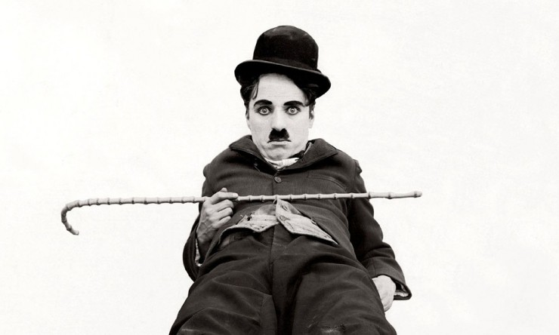
School :
Ort Ebin

Group members:
Shachar Bashkin יב6
Adi Cohen יב4
Galor Baltouh יב6

Our teacher:
Mira

Contents
Introduction……………………………………………………………...….page 1

Timeline……………………………………………………....………...…..page 2

Biography……………………….……………………………………...…..page 3

Summaries………………………………………………………………....page 4

Imaginary interview………………………………………………………..page 6

Bibliography…………………………………………………...…………...page 8

Conclusion…………….………...……………………………………..…..page 9

Appendix……………………………..……………………………….......page 10

Reflection………………………………………………………………….page 21

Vocabulary………………………………………………………………..page 22

Conclusion
We wanted to learn about Charlie Chaplin Because all of us knew and loved him and wanted to learn if we made a change in other people lives, our research question was “How did he impact people’s lives and what kind of an actor Chaplin was?”.
We went online and read about his life, one of us read his autobiography and we knew his life and how during that time he affected other people's lives. We looked at his movies and saw how his acting reached out to his audience. Our findings were that Chaplin’s character was identified in the hearts of audience as a poor soul looking to find a place. We loved looking into Chaplin's life and career and learned how from zero you can rise to the one of the greatest icons of the human experience and hope more will know about him.

Vocabulary
- Therefore - לכן
- Hence – מכאן
- However – לעומת זאת
- In light of – לאור הנ"ל
- as mentioned - כאמור
- Criticized – העביר ביקורת
- turnover – להתהפך
- role model – מודל לחיקוי
- impact – השפעה
- Overcame – התגבר
- Identify – להזדהות
- Influential – בעל השפעה
- Struggle – להתאמץ
- Potential – פוטנציאל
- Novelty – חידוש
- World view – ראיית עולם
- Particularly – במיוחד
- Society – קהילה
- Poverty - עוני
- Comedy icon – אייקון קומדיה

